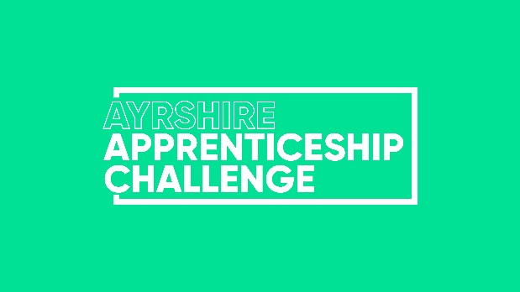


Calling all Ayrshire companies with amazing apprentices!
The Ayrshire Apprenticeship Challenge is back for 2025, offering a fantastic opportunity to give back to your community while developing the skills and talent of your apprentice workforce.

Here's why you should participate:
- Make a positive impact: Your apprentices will plan, develop, and complete a project that benefits your local community. Past projects have included everything from building additions to playgrounds to fundraising for charities!
- Empower your apprentices: The challenge gives them ownership and responsibility - a chance to shine and showcase their abilities beyond the everyday.
- Boost morale and engagement: Working on a meaningful project together fosters teamwork and creates a more engaged and motivated apprentice team.
- Attract and retain top talent: Highlight your commitment to social responsibility and employee development, making your company a magnet for talented young people.

What kind of projects are eligible?
The sky's the limit! Think building, decorating, event planning, fundraising, raising awareness, or educating. Whether it's physical (like building an item for a community garden) or more administrative (like organising a charity run), the key is to make a positive difference.

Who can enter?
Open to companies with one or more apprentices (Foundation, Modern, or Graduate).
We welcome 3 different types of ‘teams’:
- Individuals
- Company Teams
- Blended teams (Blended teams could be made up of students from the same course at College)

What is the timeline?
- Monday 14th July 2025- Deadline for Registration
- August- January 2025 – Completion of project
- Tuesday 2nd September 2025– Optional Team building workshop
- Tuesday 16th September 2025 – Optional Leadership workshop
- Wednesday 26th November - Optional Report/Portfolio workshop
- Wednesday 21st January - Optional Presentation Skills workshop
- Friday 30th January 2026 (no later than 5pm)– Portfolio Submission Deadline
- Tuesday 3rd March 2026– Final Event during Scottish Apprenticeship Week

Spread the Word!
We encourage you to promote the Ayrshire Apprenticeship Challenge within your company and community.

Media Coverage:
To ensure proper recognition for everyone involved, please include the following details in any media coverage related to the Challenge:
- Initiative Name: Ayrshire Apprenticeship Challenge
- Participating Organisers: Ayrshire Chamber of Commerce & Industry and DYW Ayrshire
For questions or media release review, contact Emma McClymont emcclymont@ayrshire-chamber.org

Ready to join the Challenge?
Fill out the simple registration form below and submit it to Emma McClymont at emcclymont@ayrshire-chamber.org and return by Monday 14th July 2025.

Employer Registration Form

Organisation Name:

Main Contact Name & Job Title:

Main Contact Email:

Company Address:

Telephone Number:

Number of Apprentices Involved:

Names of Apprentices Involved:

Contact Email of ALL Apprentices Involved:

Apprenticeship Type(s): (Foundation, Modern, Graduate)

Apprenticeship Framework(s):

Proposed Challenge: Briefly describe your project idea.

Project Sourcing Help: Do you need assistance finding a project? | YES | NO
Team Building Workshop-Tuesday 2nd September: Are you interested attending and how many spaces do you require? | YES  No of Spaces: | NO
Leadership Workshop- Tuesday 16th September: Are you interested attending and how many spaces do you require? | YES  No of Spaces: | NO

